| AEPSY2024  **Year 11 ATAR PSYCHOLOGY Name:** | |
| --- | --- |
| Task No: | 6 |
| Task Type: | Inquiry: Research |
|  |  |
| Content: | Attitudes and Prejudice |
|  |  |
| Total Marks | 50 |
|  |  |
| Weighting | 15% |
| Description | In class research (2 weeks) |

**Conduct an original research investigation into attitudes and prejudices towards different generations in the workplace.**

https://hbr.org/2022/03/is-generational-prejudice-seeping-into-your-workplace

**Students must design and conduct an original research investigation into attitudes, then analyse data and critically evaluate the results.**

**We will collate the questions and send out a single questionnaire to all participants. A consent form will be required and handed out with the survey.**

**Conditions**

Time for the task:

* Two weeks to plan survey questions, conduct the investigation, collect the data and research studies about the attitude topic.
* During this time you will write up your method, table, graph and briefly summarise your results as per the report requirements.
* One period to write the abstract, introduction, discussion and conclusion under test conditions.

Materials required when writing the Abstract, Introduction, Discussion and Conclusion:

* method
* results section – including data (tables and graphs)
* list of references
* a half-A4 page of notes, size 11 Calibri or Times New Roman, **must be dot points**

You must also consider how you will address the ethics involved in any investigation.

**Due date: Total Mark: / 50**

Example:

Youth and Parental Attitudes Towards the Use of Social Media.

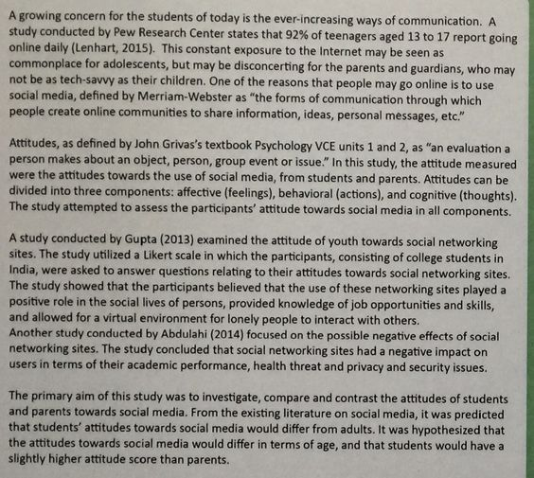

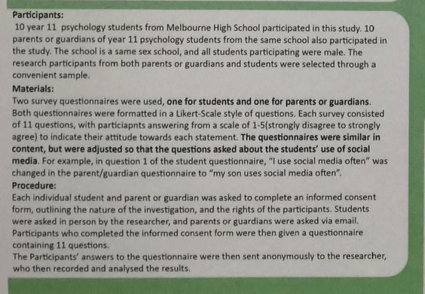

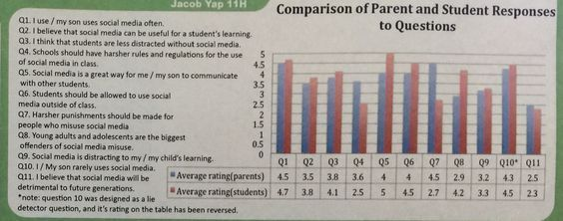

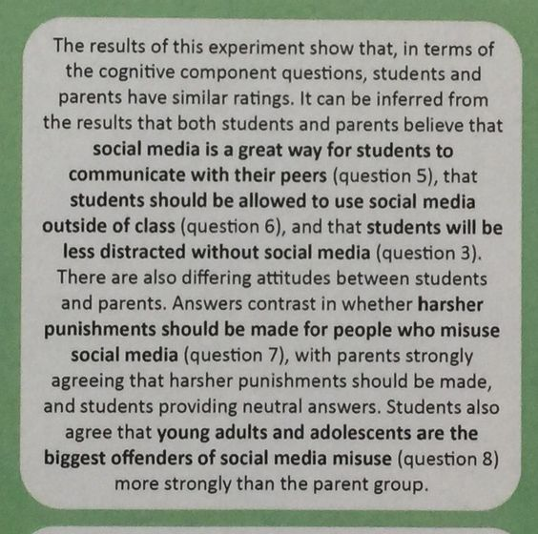

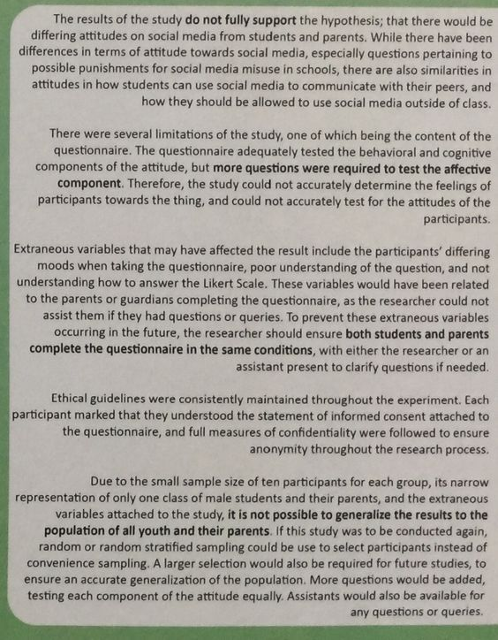

**MARKING KEY**

|  |  |
| --- | --- |
| **Description** | **Marks** |
| **Abstract** |  |
| * Succinctly writes a specific aim | 2 |
| * Provides a general aim | 1 |
| * Briefly describes the method, including * Participants * Materials used * How the task was administered | 1 - 3 |
| * States the results of the research | 1 |
| * Draws a relevant conclusion | 1 |
| **Subtotal** | **7** |
| **Introduction** |  |
| * Makes a relevant statement about Attitudes | 2 |
| * Makes some comments about Attitudes | 1 |
| * Supports above information with reference to relevant research | 2 |
| * Refers to some research without making links to the topic | 1 |
| * Writes an operational hypothesis that follows on logically from the aim | 2 |
| * Poses a research question/prediction | 1 |
| **Subtotal** | **6** |
| **Method** |  |
| * describes participants in sufficient detail to be replicated, e.g. number, age, gender * describes the selection process | 1–2 |
| * describes materials in sufficient detail to be replicated | 1–2 |
| * describes the procedure including:   + addresses anonymity   + describes task in sufficient detail to be replicated   + describes the collection, collation and presentation of questionnaire results | 1–3 |
| **Subtotal** | **7** |
| **Results** |  |
| * organises all relevant data logically in correctly labelled tables   + correctly organises table   + correctly labels table including units where appropriate   + includes relevant data | 1–3 |
| * presents data in a graph * correctly graphs data * uses appropriate labelling * uses appropriate titles | 1–3 |
| * states results of the investigation * provides an accurate summary of the data | 1 - 2 |
| **Subtotal** | **8** |

|  |  |
| --- | --- |
| **Discussion** |  |
| * discusses the results of the investigation, relates the results to the hypothesis and explains how they relate to relevant psychological theories/research (which were introduced in the introduction) | 4 |
| * discusses the results of the research, comments on the hypothesis and describes relevant psychological theories | 3 |
| * describes what happened in the investigation and cites relevant psychological theories | 2 |
| * describes what happened in the investigation | 1 |
| * evaluates the investigation design:   + discusses any methodological flaws   + explains steps taken to ensure reliability and how it could be improved | 3 |
| * explains how variables were controlled and suggests ways to improve reliability | 2 |
| * states that variables need to be controlled and suggests how to improve reliability | 1 |
| * discusses ethical issues and describes how these were addressed | 2 |
| * refers to ethical issues that were considered in the investigation | 1 |
| * discusses relevance of results to the population from which the sample was drawn as well as to theory or other research referred to in the introduction | 2 |
| * suggests how the investigation might be of relevance to science or society | 1 |
| * makes accurate conclusions that relate to the hypothesis or research question | 2 |
| * forms an accurate conclusion but does not relate it to the hypothesis or research question | 1 |
| **Subtotal** | **13** |
| **References** |  |
| * includes a range of relevant references * includes some relevant references | 2  1 |
| * Correct end-text referencing (inc. listed alphabetically) | 1 |
| * Correct in-text referencing (inc. quantity) | 1 |
| **Subtotal** | **4** |
| **Appendix** |  |
| * appends data sheet (raw data) | 1 |
| **Subtotal** | **1** |
| **Clarity of expression** |  |
| * Quality of spelling and grammar | 1-2 |
| * Correct use of headings, organised, presented in APA format | 1 |
| * Written in passive voice | 1 |
| **Subtotal** | **4** |
| **Total** | **50** |